1. Creating a Internal table:

CREATE TABLE IF NOT EXISTS EMPLOYEE_INTERNAL (eid int, name String,

salary String, destination String)

row format delimited

fields terminated by ‘,’;

OK

Time taken: 2.057 seconds

1. LOADING data from Local:

hive (hive)> load data local inpath '/home/training/Desktop/Hive/employee' into table employee;

By default internal tables are stored in path : **/user/hive/warehouse/hivedb.db**

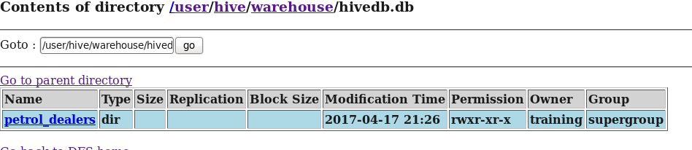

1. Loading data into table from HDFS:

First make sure the data is in HDFS path.

hadoop fs -put '/home/training/Desktop/Hive/employee.txt' /home/training/Desktop/Hive;

**hive> load data inpath '/home/training/HIVE/petrol.txt' into table petrol_dealers;**

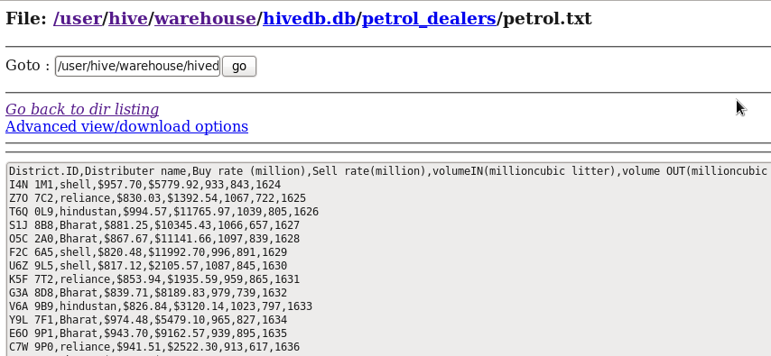

External table:

CREATE EXTERNAL TABLE **petrol** ( distributer_id string, distributer_name string, amt_in string, amy_out string, vol_in int, vol_out int,

year int)

ROW FORMAT DELIMITED

FIELDS TERMINATED BY ','

STORED AS INPUTFORMAT

LOCATION

'/home/training/HIVE/';

Here it wont create any table name - directory under this path as it created in internal table.-- ‘/HOME/TRAINING/DESKTOP/’

But it is just trying to refer the mentioned location ---- ‘/HOME/TRAINING/DESKTOP/’

**Point to note here is**: When we load the data to external table, it is going to create directory of file name under this path not with the table name.

Here external table name : petrol

Data stored under name: /HOME/TRAINING/DESKTOP/DATA.

After loading into table, it will create directory under file name not with directory name ---DATA

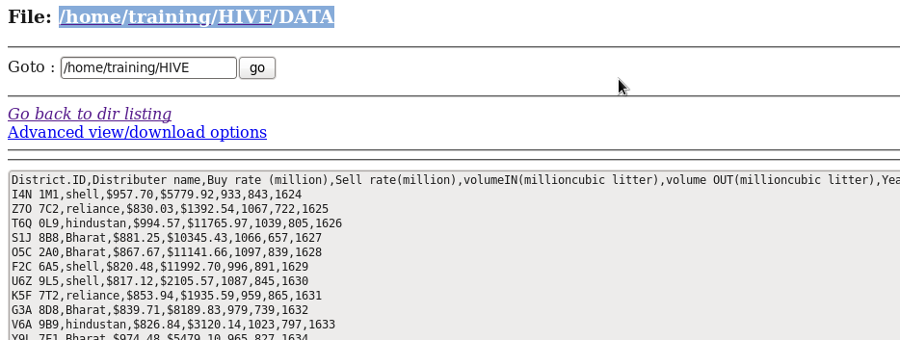

In internal tables, one file is referred by only one table,

**But where as in external table, one file can be referred by multiple table.**